# JIT121 Programming Principles Tutorial 3

## Learning Objectives

1. Following Coding Conventions
2. Understanding the **for** loop construct
3. Understanding the equivalence of loop constructs (**for**, **while**, **do while**)
4. Experience working with arrays and **List**s
5. Introduction to the Visual Studio Debugger

## Assumptions

That you are already familiar with Lectures 1 – 3 & Tutorials 1 – 2

## Activity Overview

1. Coding Conventions for JIT121
2. Key Concepts – Arrays
3. Using a **for** loop
4. Rewriting **for** loop as **while** or **do while**
5. Array of Array Example
6. Using a **List**
7. Introduction to the Visual Studio Debugger

**Activity 1: Coding Conventions for JIT121**

Software Development organisations adhere to specific sets of guidelines in respect to writing programs in a particular programming language. These guidelines are aimed at improving readability and understandability of the code by maintaining a consistent structural style to the code so that anyone within the organisation can modify the code and maintain a high level of consistency. These guidelines are called **Coding Conventions** and usually include commenting styles, declarations, indentation, statement layouts, naming conventions, use of white space as well as other software quality and presentation issues.

The C# Language Specification did not include a Coding Standard unlike Java when it was released. In this unit you must follow the Coding Convention set out in JIT121 **C# Coding Style Guide**.

We will discuss this guide and demonstrate how to change some of the options within the VS C# text editor. Ensure that all your assignments adhere to Style Guide. In particular, pay special attention to:

* horizontal whitespace (tabs and whitespace);
* line length;
* vertical whitespace (line spaces between blocks of related code);
* placement of open/close braces
* identifiers (variable and method names)
* documentation (commenting at class, method and line/block level )
* magic numbers and constants

### Activity 2: Key concepts - Arrays

Unzip the file **KeyConcepts_ARRAYS.zip**, and run the exe file contained withinand complete the exercise.Talk to me if you do not understand the correct answers.

**Activity 3: A for loop exercise**

Scenario: You have just imported an American car, a Chevy Impala. The car’s speedometer works in miles per hour (mph). As you do not wish to obtain a speeding ticket for exceeding the speed limit, you decide to write a program which will display a table of speeds in kilometres per hour (kph) with the corresponding speed in mph.

1 kph = 0.62137 mph

The table will show the speed in kph with the corresponding speed in mph similar to below:

KPH MPH

10 6.21

20 12.43

30 18.64

…

100 62.14

110 68.35

Write a program to produce this table using a **for** loop, where the loop's index variable will be kph value starting at 10, and ending at 110. For the purpose of this workshop exercise, this program can be written as straight line code within **Main**. This program will not require any input from the user.

### Activity 4: All loop structures are equivalent

Make a copy of the previous activity's solution. (Either copy the entire project or simply copy and paste the .cs file inside the same project). Rename the project/file to include "**… using while loop**", to distinguish it from the previous solution.

In the new file, replace the **for** loop with a **while** loop.

Be sure to show your solution to me in class. As a homework exercise, replace the **while** loop with a **do while** loop.

**Activity 5: Array of array Example**

Add **T3_Scoring.cs** to an existing VS project. Running this code will produce the following output:

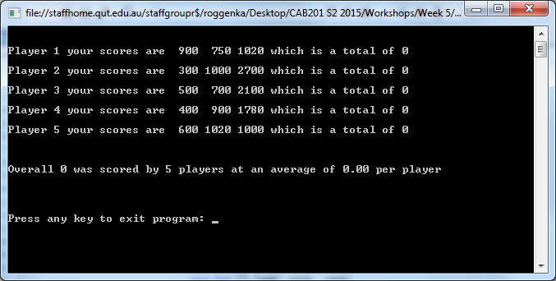

Look at the code. It is complete apart from one method, **SumArray**, which is intended to add all of the elements of the array passed as the parameter and return that total. At the moment, this method is simple a stub.

Read and understand why the program produces the above output. Now complete the method **SumArray** which requires a simple **for** loop. Once completed correctly, your program should produce the following output:

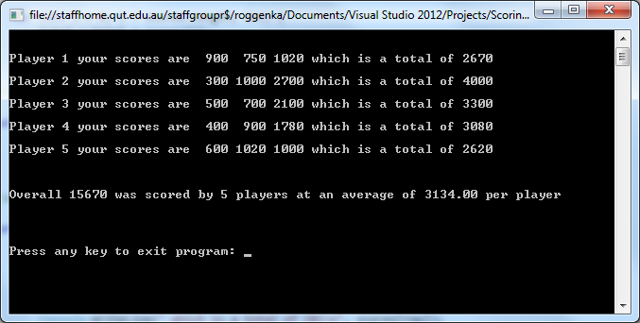

**Activity 6: Using a List**

For practice with arrays and lists, add the file **T3_Beetles.cs** to an existing VS project. There are several places in the supplied program that are yet to be implemented. Complete the implementation as suggested by the comments. The output from your completed program should be something like:

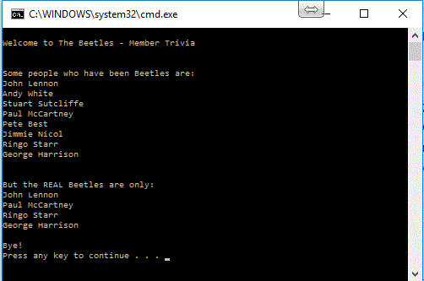

### Activity 7: Analysing Code

Referring to the code below, answer the following questions:

**public** **static** **int** UnknownMethod(**int**[] values) {

**int** j = 0;

**for** (**int** i = 0; i < values.**Length**; i++) {

**if** ((values[i] % 2 == 0) && (values[i]!= 0)) {

j++;

}

}

**return** j;

}

1. In plain English, describe the purpose of this code. Do not give a line-by-line description of it, but rather summarise its purpose. Provide a method call with concrete values for the array elements, as well as the expected output returned by the method.
2. Provide a trace table for a call to this method where values contains:

{ 1, 0, 12, 9, 2 }